Shreebuvan V(CB.EN.U4CSE17055)

**End Sem Project Documentation**

TOP LIST BLOG

A PERFECT PLATFORM

Abstract

The ‘TOP List Blog’ is a platform where different users can come see the various posts on the TOP’s (best) available for the given topic. The user will also be able to post his own posts if he is a registered user. The user has facilities for updating and deleting the posts that he/she has created. There is also a unique account details page for each registered user where the user can update their profile image and also update their personal details. Pagination has also been done in limiting the number of posts per page which is more flexible for users.

There is also an exclusive TOP Books in Selected Category Section available for all the users where they are given with a list of TOP books available in different categories. The user can select the category that they would like to explore by entering the number besides each category in the input field present at the top of the webpage. Then the user is given with a list of the TOP Books available in each category with the prices of each accompanying the title of the book. The user is also given recommendation of the books that the other users have searched for if he/she is in the login.

The detailed description of all the intricate details which in present in the applications is discussed in this documentation.

The various features with are present in the web-application is discussed in details with code snippets given wherever possible along with how the features looks like in the web-application.

Followed by the various Methodologies which has been included in the project and some of the additional features which will be helpful for troubleshooting.

How to run it!!!

**Using PyCharm:**

1.Open PyCharm and open the folder in which the program files are stored.

2.Run the command *python run.py in the terminal*

*3.Open Google Chrome and search for localhost:5000/home*

*4.There comes the Homepage for TOP LIST BLOG.*

**Using Command Prompt:**

1.Open Command Prompt with project folder as current directory **(Note: Using PyCharm would be preferable as SQLite is required and few imports has to be done which is fast in PyCharm)**

2Run the command *SET FLASK_APP=run.py*

3.Run the command *flask run*

*4.Open Google Chrome and search for localhost:5000/home*

*5.There comes the Homepage for TOP LIST BLOG*

How does it look like?

Home Page:

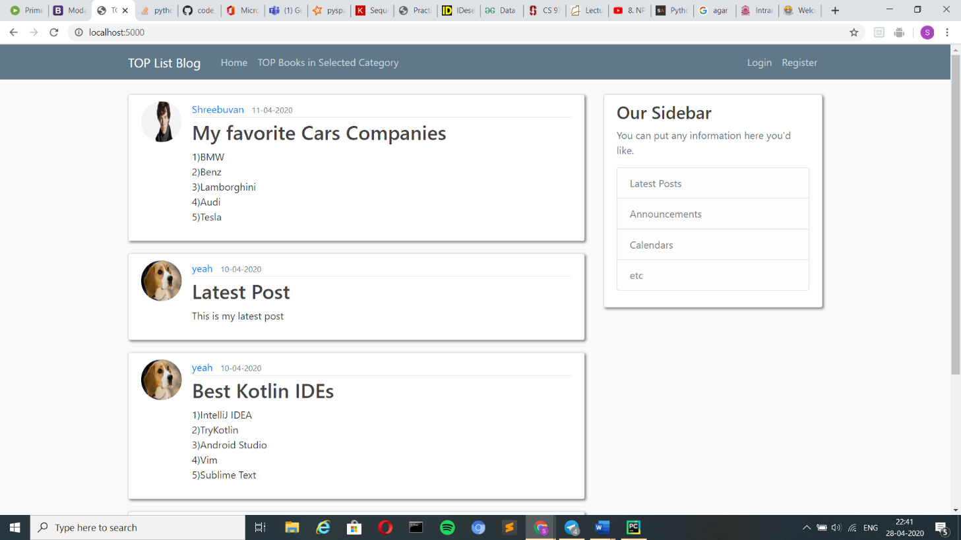

Description:

* This is the home page where we find all the posts of different users with their username, profile pic, time of creation and the post content arranged in the order of the time of creation of the respective posts.
* Pagination is included for better user experience. (Limited to four posts per page)

How does it look like?

Login/Sign in Page:

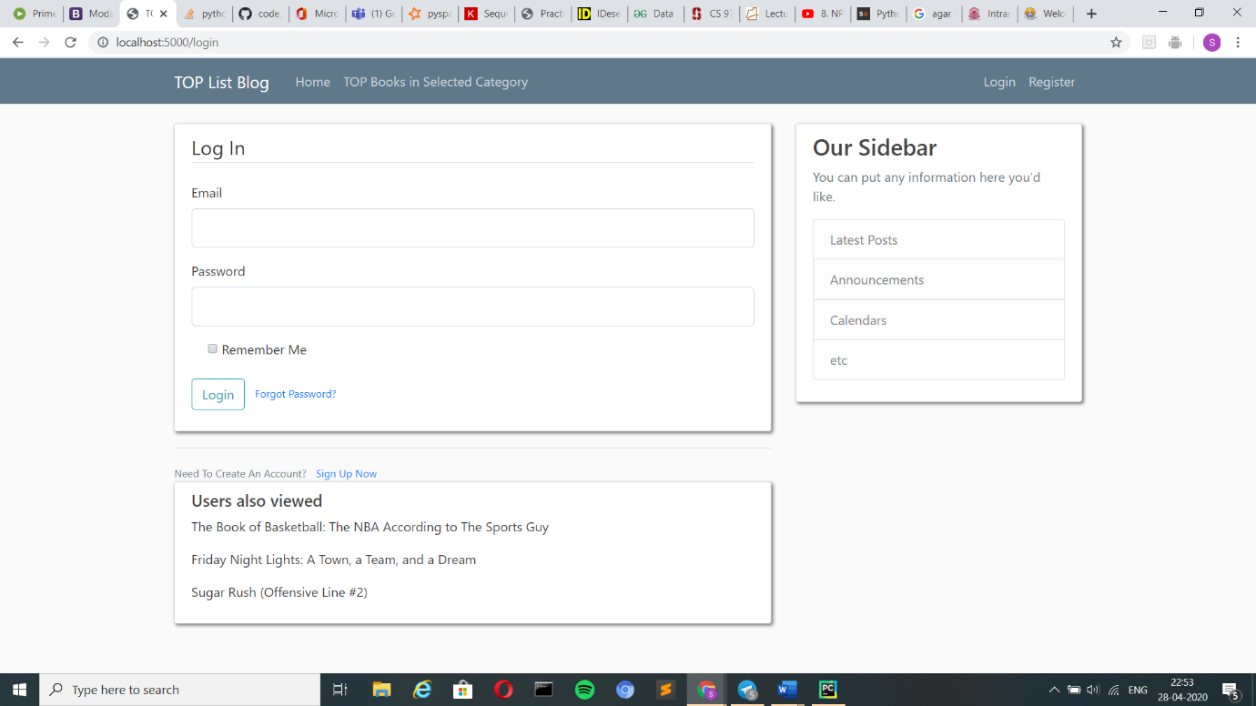

Description:

* Login page where the user gives his username and password which gets validated at the user is logged. (Available email: password pairs are boom@gmail.com: boom, yeah@gmail.com: yeah, boomyeah@gmail.com: boomyeah, shreebuvan99@gmail.com: shreebuvan)
* Forgot Password helps in updating the password. (To use this feature the permissions for allowing access to less secure apps should be given for the google account of the user)
* When the user does not have an account, he can click on the Sign Up which redirects the user to the Sign Up/Register page.

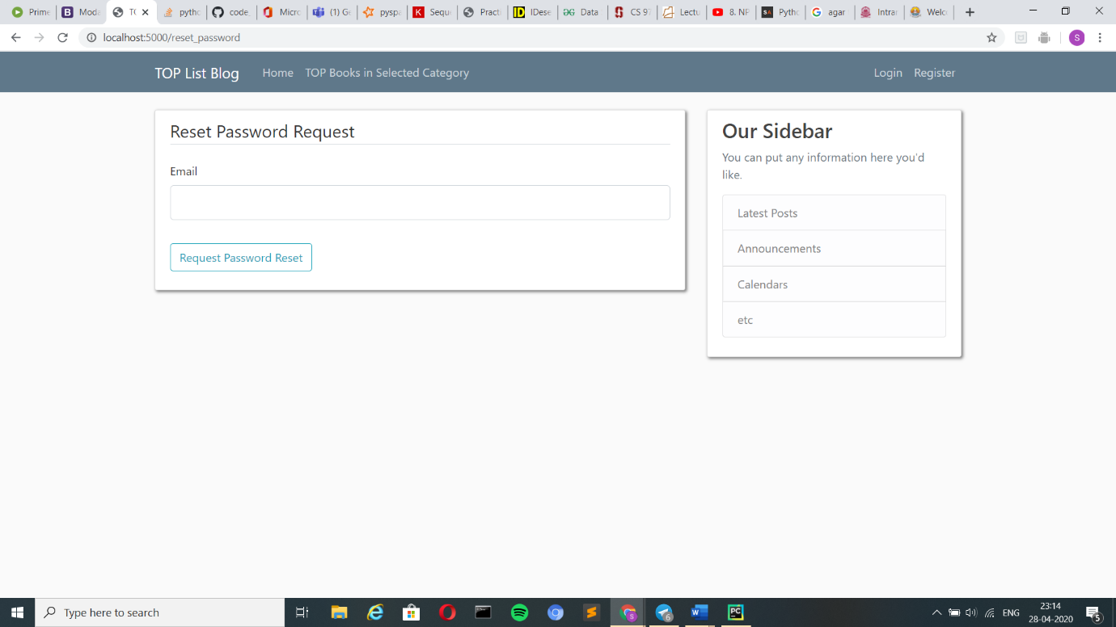

* The request for password reset should be given and an no-reply email is send to the email id

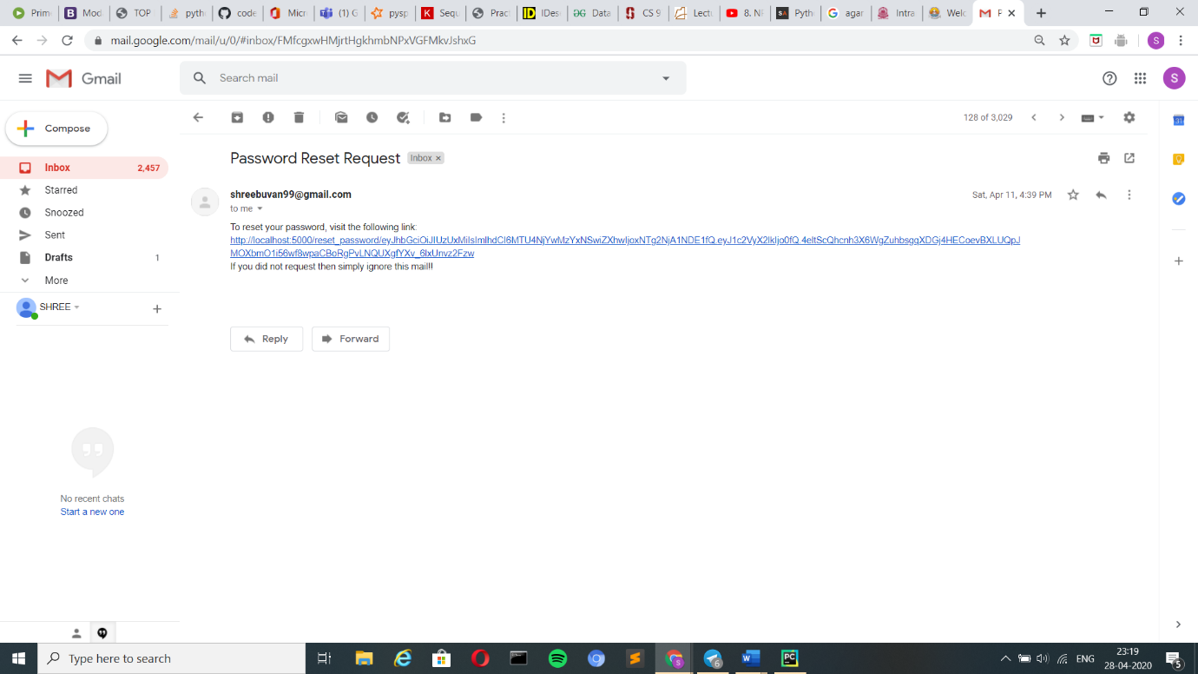

* The reset password link has to be clicked and it redirects to the reset password page shown below

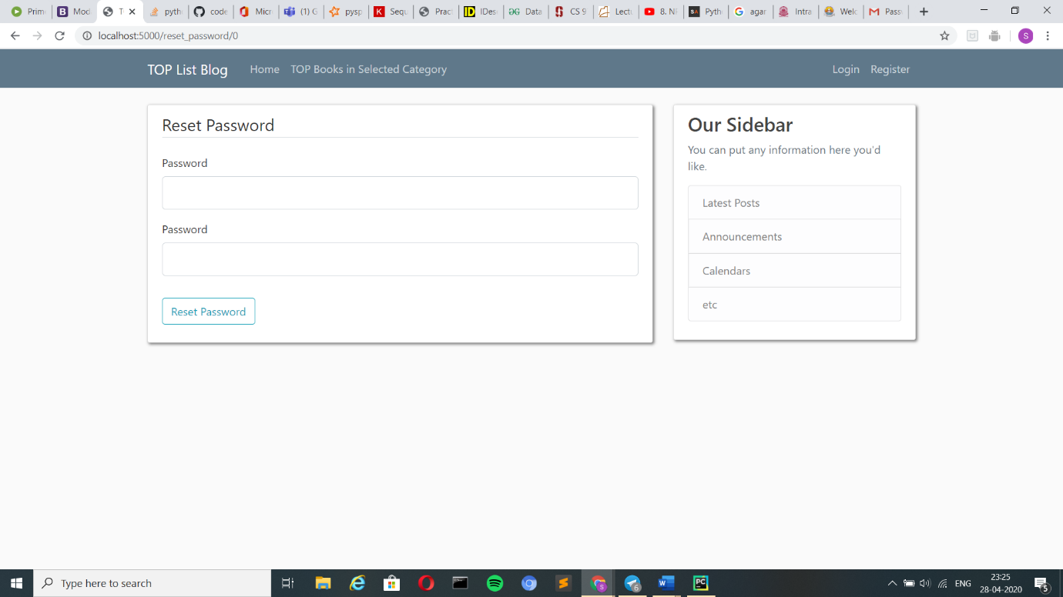

* After the new password change is confirmed we’ll get the flash message on the page as shown below.

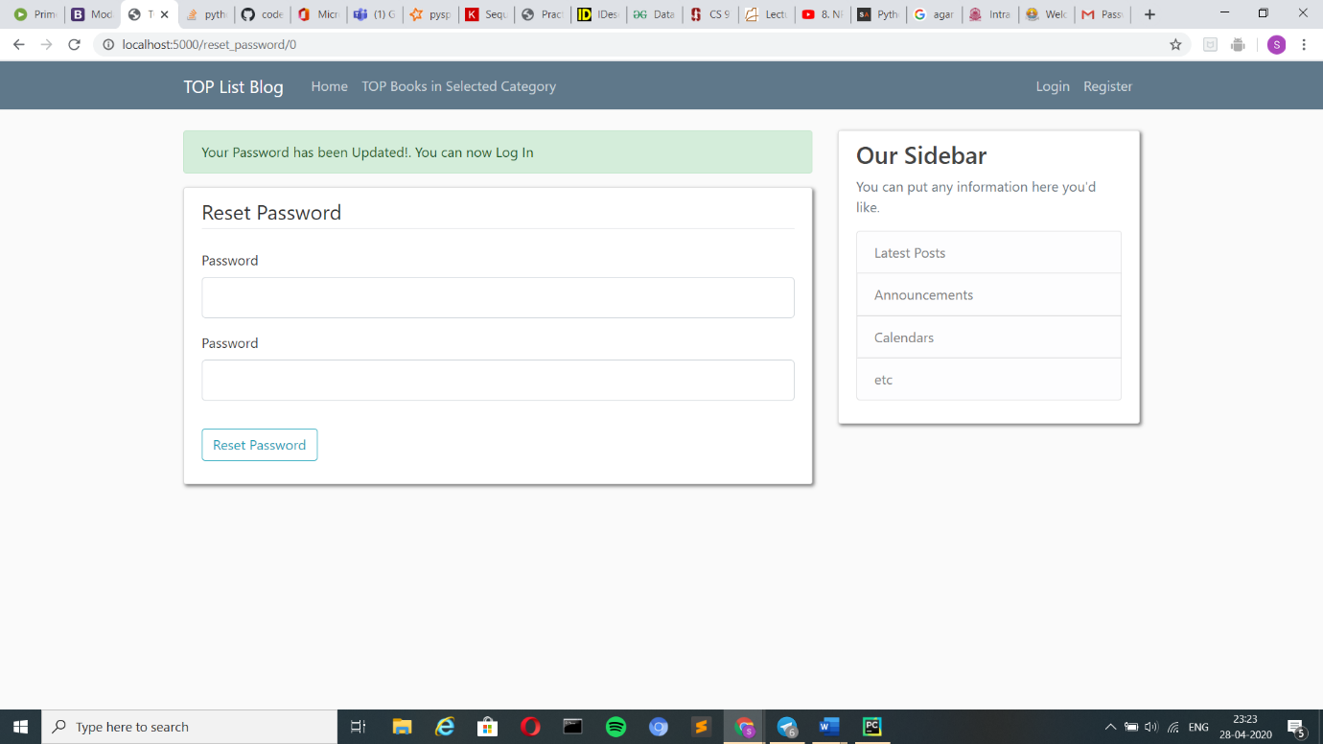

How does it look like?

Register/Sign Up Page:

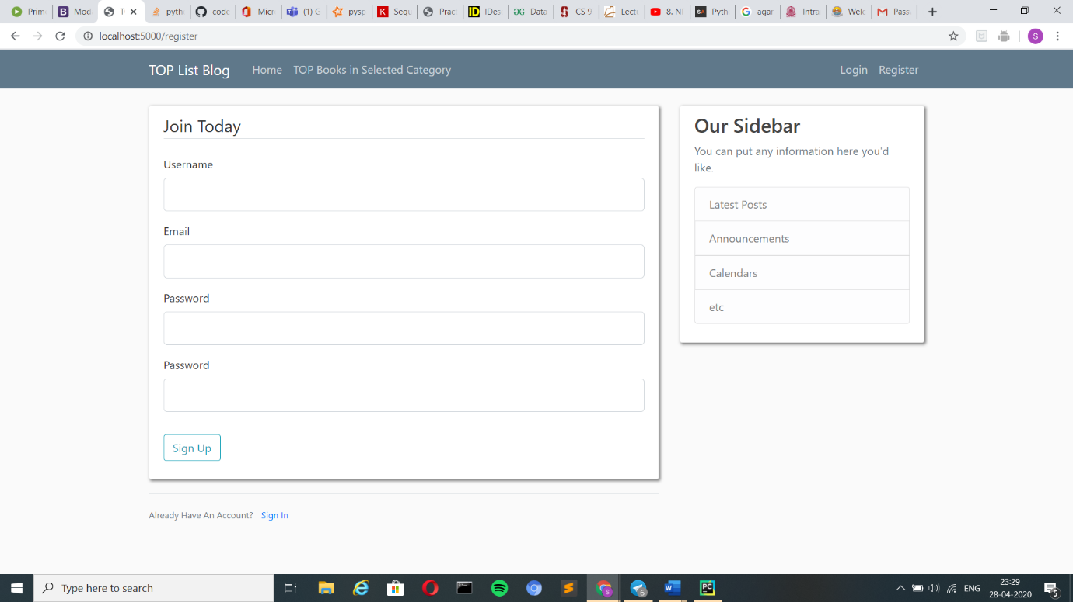

Description:

* The new user has to fill up the details of their username, email, password, confirm password for creating his/her account.
* By doing this the user can create a new account.

Note: A user cannot have multiple accounts for the same email id.

* If the user is already a registered user. The Sign In option in this page helps in redirecting the user to the Login Page.

How does it look like?

Login Not Required

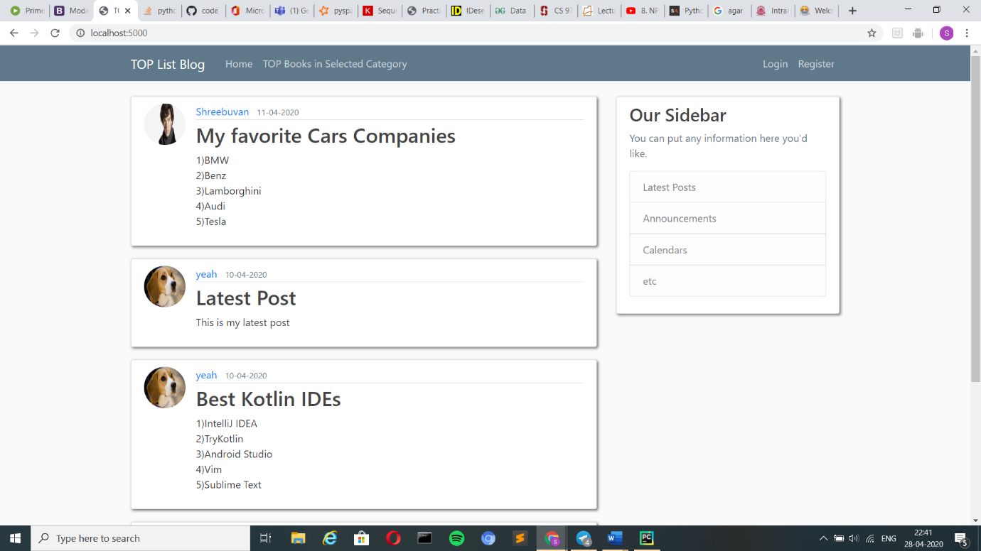

@Login Required

*WE CAN FIND NEW POST, ACCOUNT AND LOGOUT OPTION (ALL THIS IS ONLY FOR A LOGGED IN USER)*

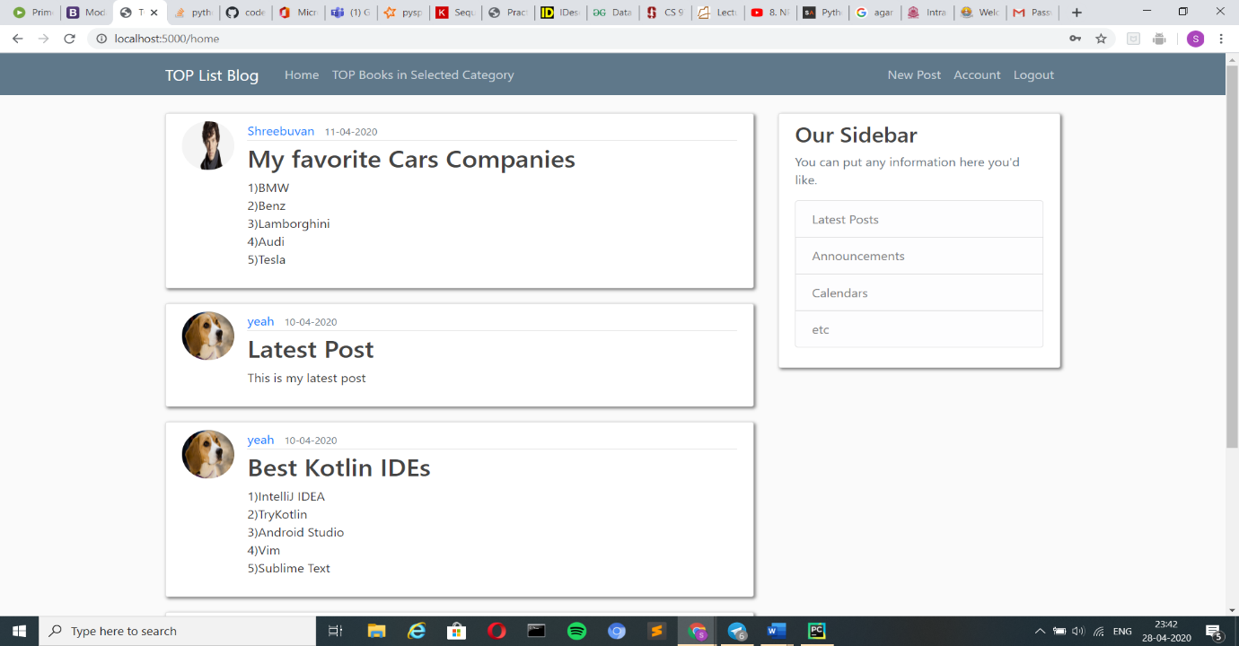

Account Page:

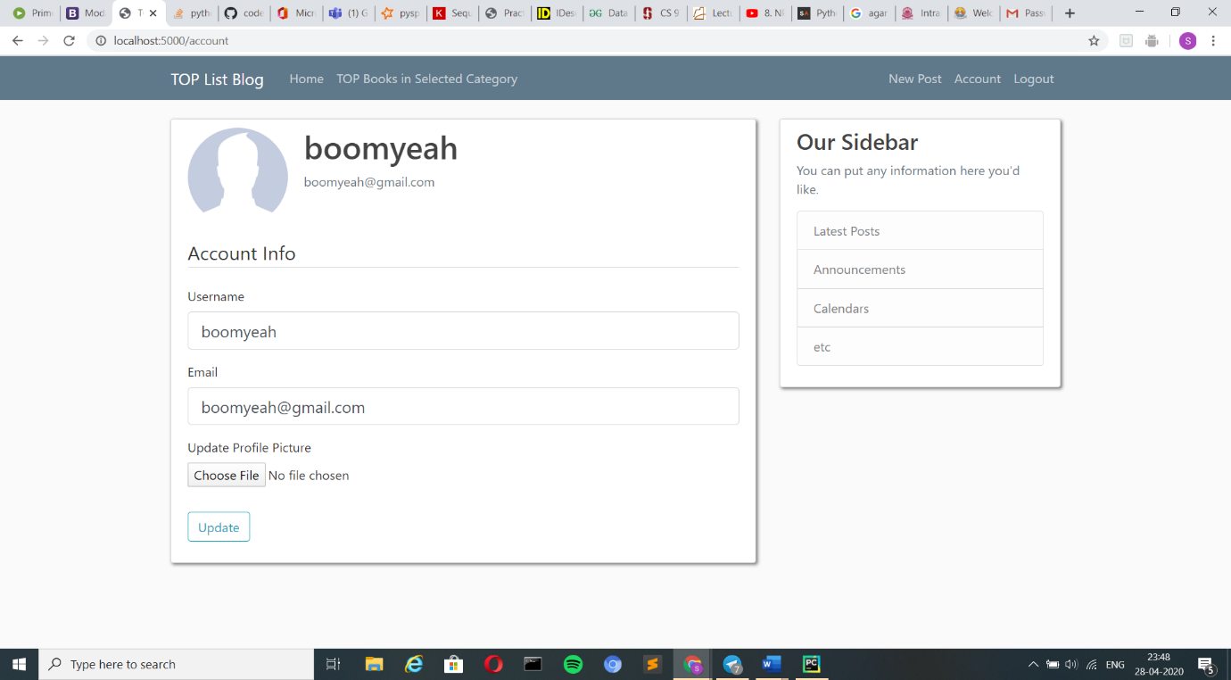

Description:

* The above image shows how the account page for a newly created user
* Where we can find details like username, email, default profile image.
* We can change the profile image for which we have choose file option is available in which the new profile image is updated (Note: The file extensions supported are .jpg, .png).
* Then the update button should be clicked for the changes to be saved
* Now after updating the profile image the account page will look as in the image given below

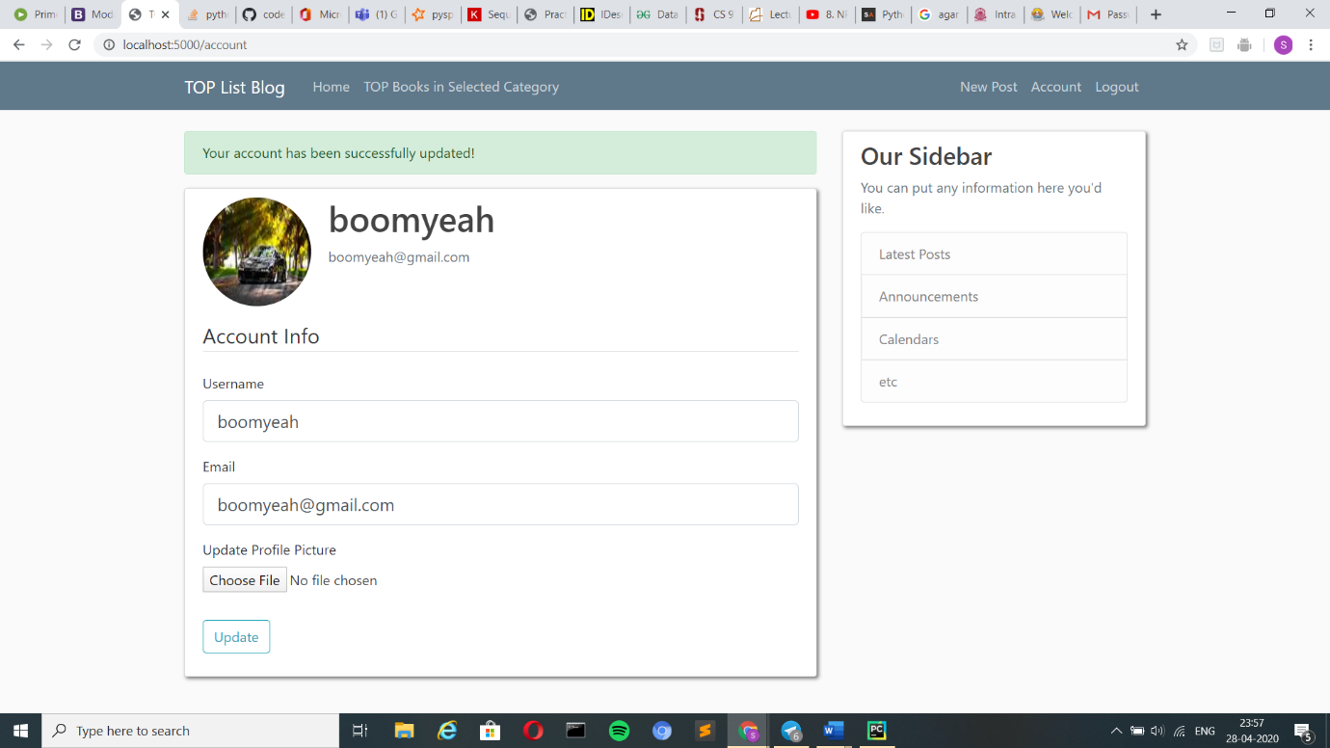

How does it look like?

New Post Page:

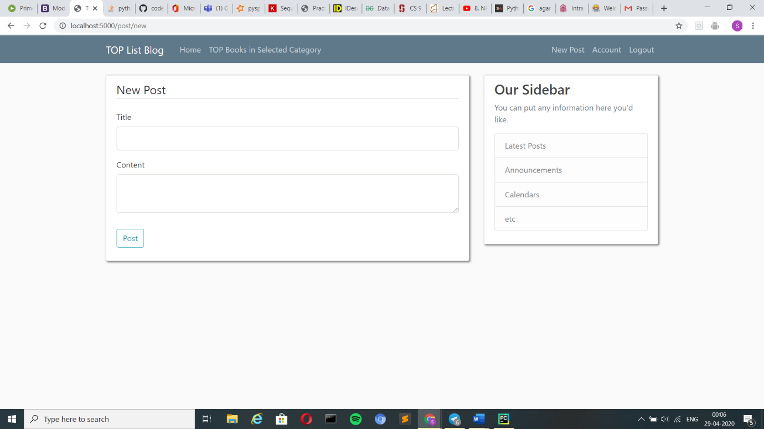

Description:

* New post can be created by entering the post title and the content of the post after which the post button should be clicked.
* Which will redirect the user to the home page where the user will be able to see his post along with the other users’ posts as shown below.

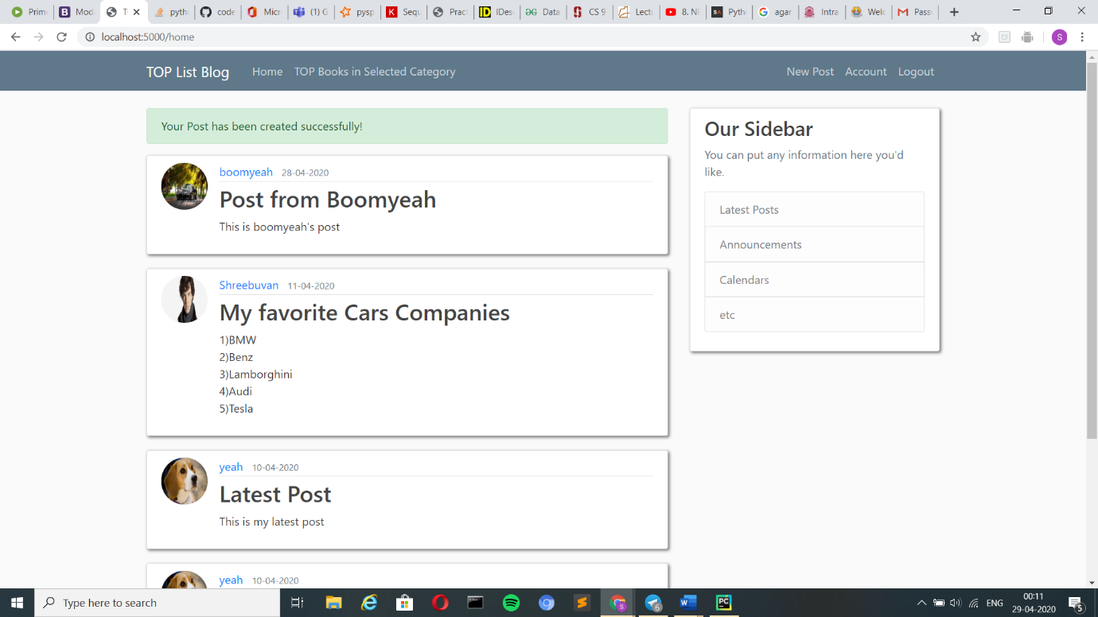

* The user can view posts from specific user by clicking on the other users’ name in the post window. The result will be as shown below.

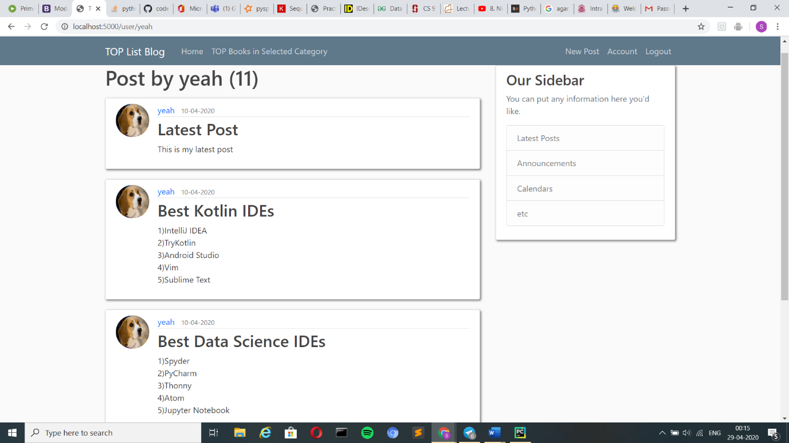

* The user can also see his own posts by clicking on his own username in the post as seen in the above. But in addition to this if the user can also update/delete his **own** posts by clicking on the title of post to which changes has to be made. The result will be as shown below.

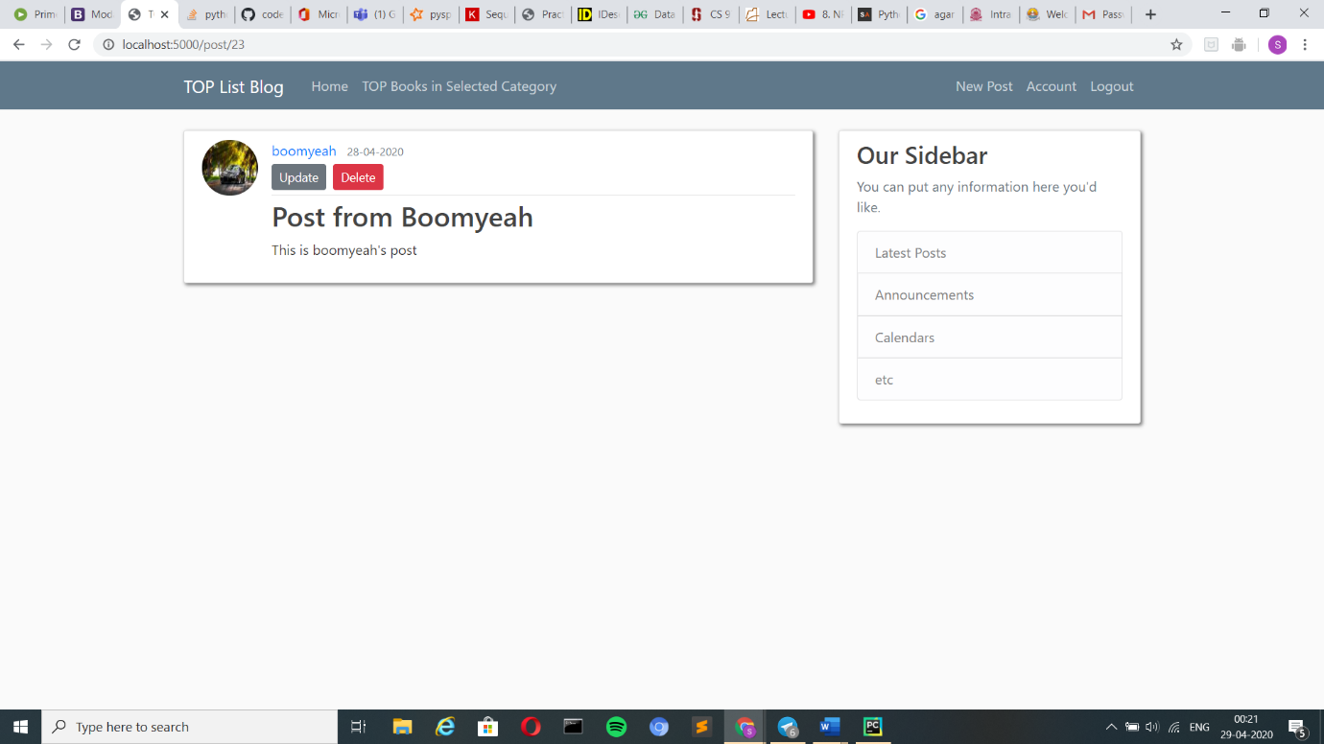

Update Option:

* When the user clicks the update button his previous details will already be filled in.
* If the user wishes to make changes to the post, he can change the title or the content of his post. Then click the post button to see the updated post in the home page. The update post, the result in the home page are shown below.

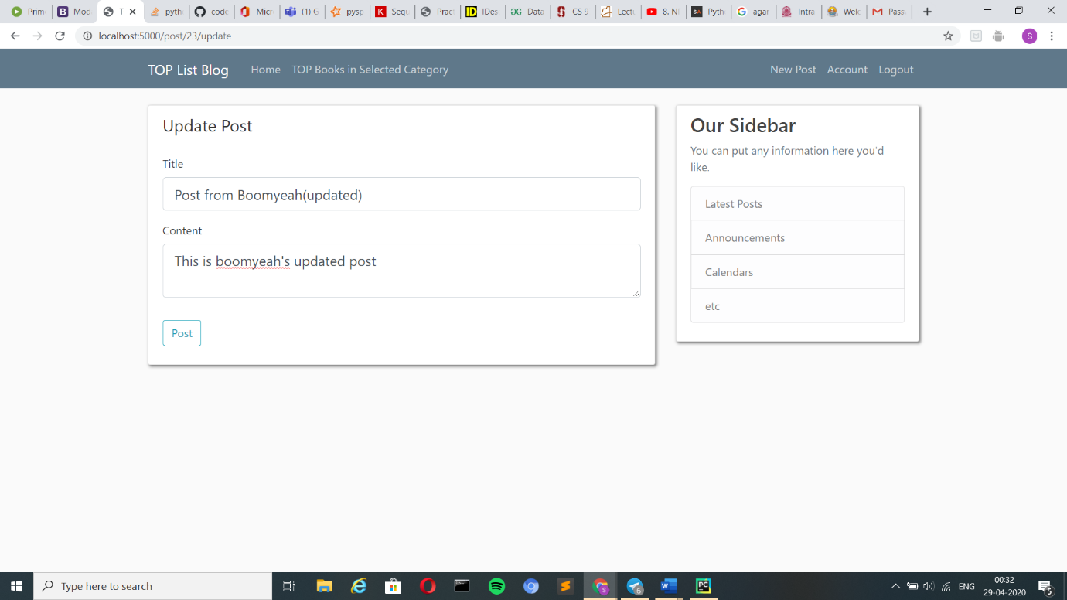

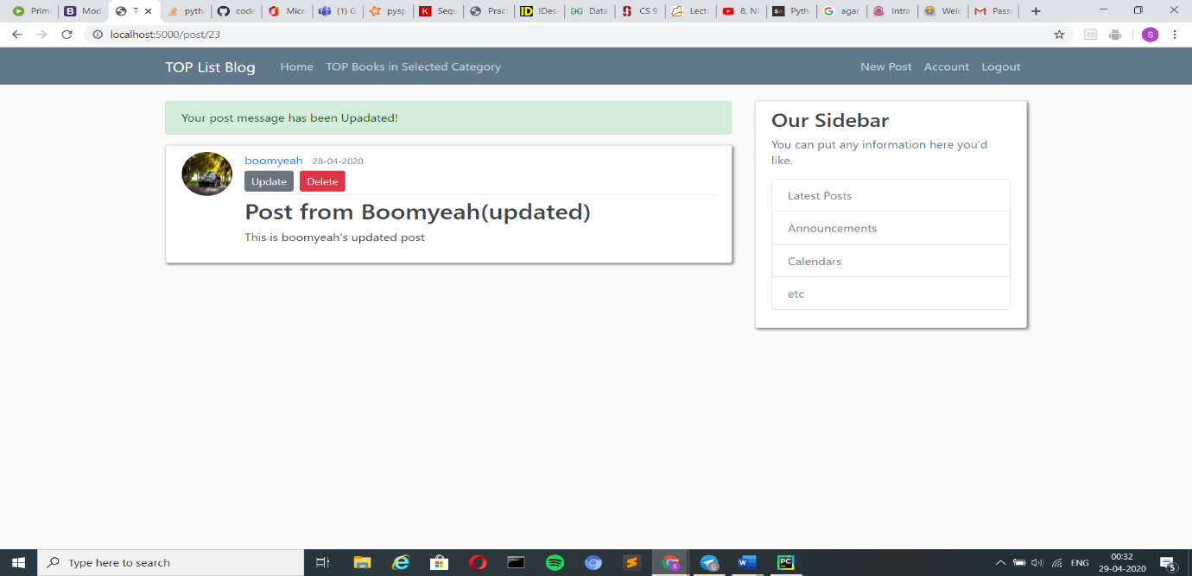

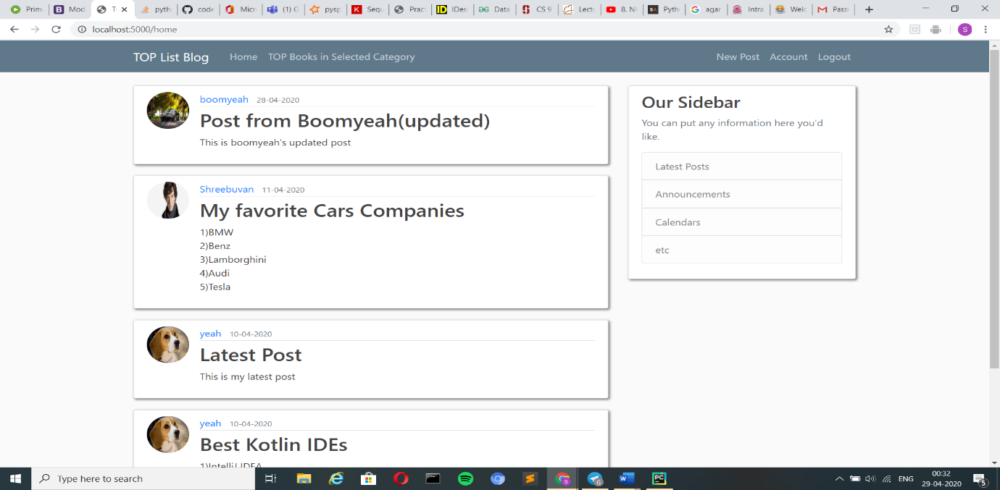

Delete Option:

* When the delete button is clicked a confirmation pop up will be seen in the screen. If the delete button is clicked then the post will be deleted.
* This result can be seen in the home page to which the control gets redirected when the delete button is clicked. This is shown in the images below.

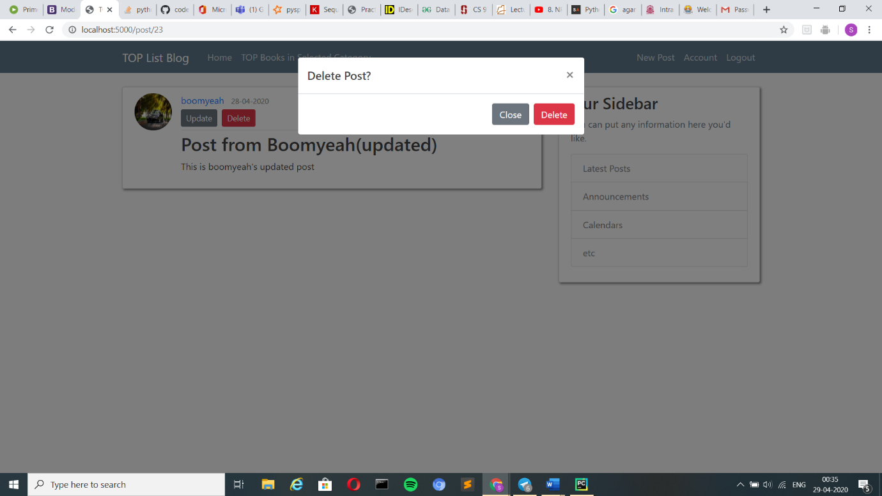

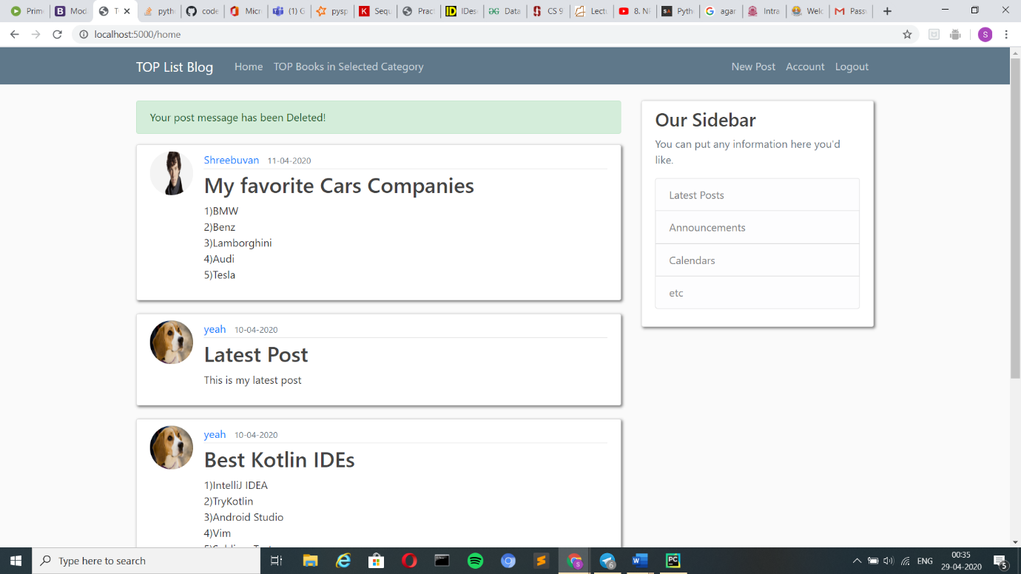

At last the logout button is clicked to log out form the user account which is no the top right corner of the page

How does it look like?

TOP Books in Selected Category Page:

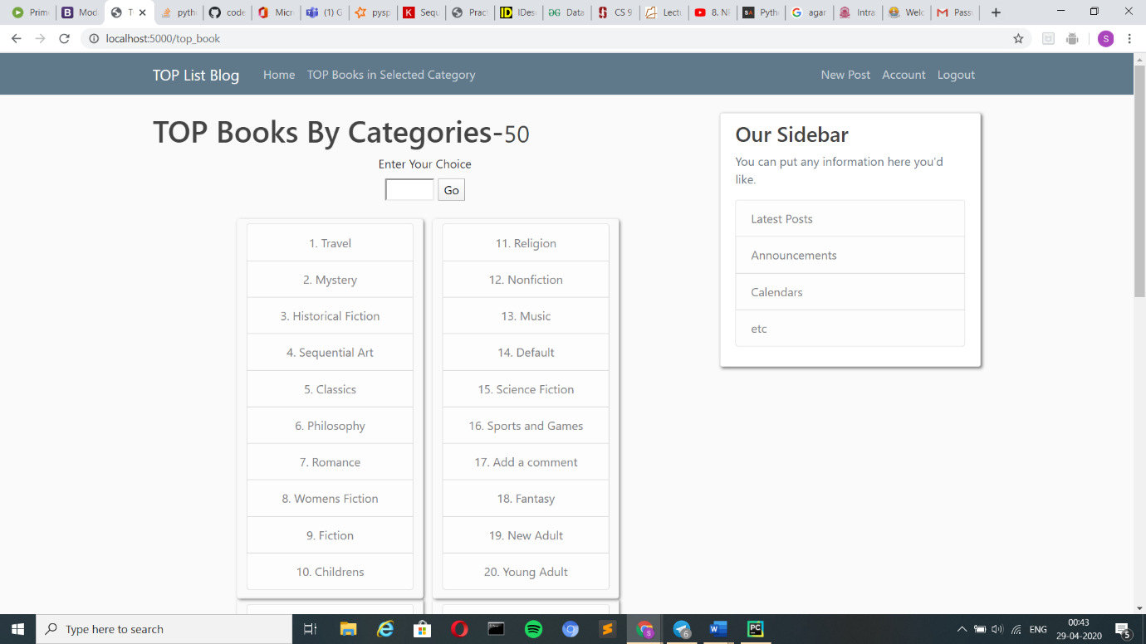

Description:

* The Image shows the list of categories available to see the title of the TOP books available in each of the category and the prices of each of the book.
* Now when the user enters the category user wants and clicks go button then the user is given with a TOP list of books available in the category along with the prices the books.

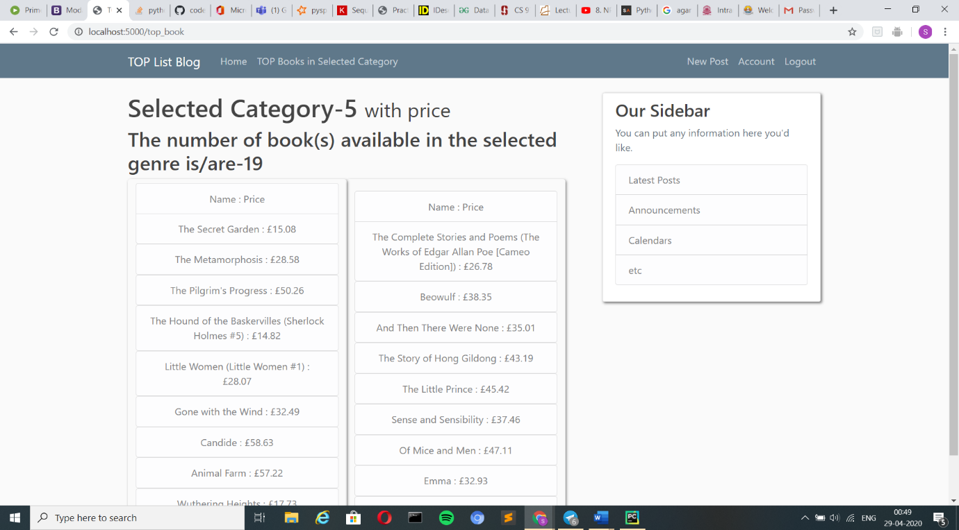

Methodologies Used:

1. Session:

* A session is nothing but the execution of the application in the given time span and the variables used for storing the information of the changes in the given session is called session variables.
* The session variable is used to send the dictionary which contains the key: value pair of category number: category type which is obtained from the webpage http://books.toscrape.com/index.html.

Code:

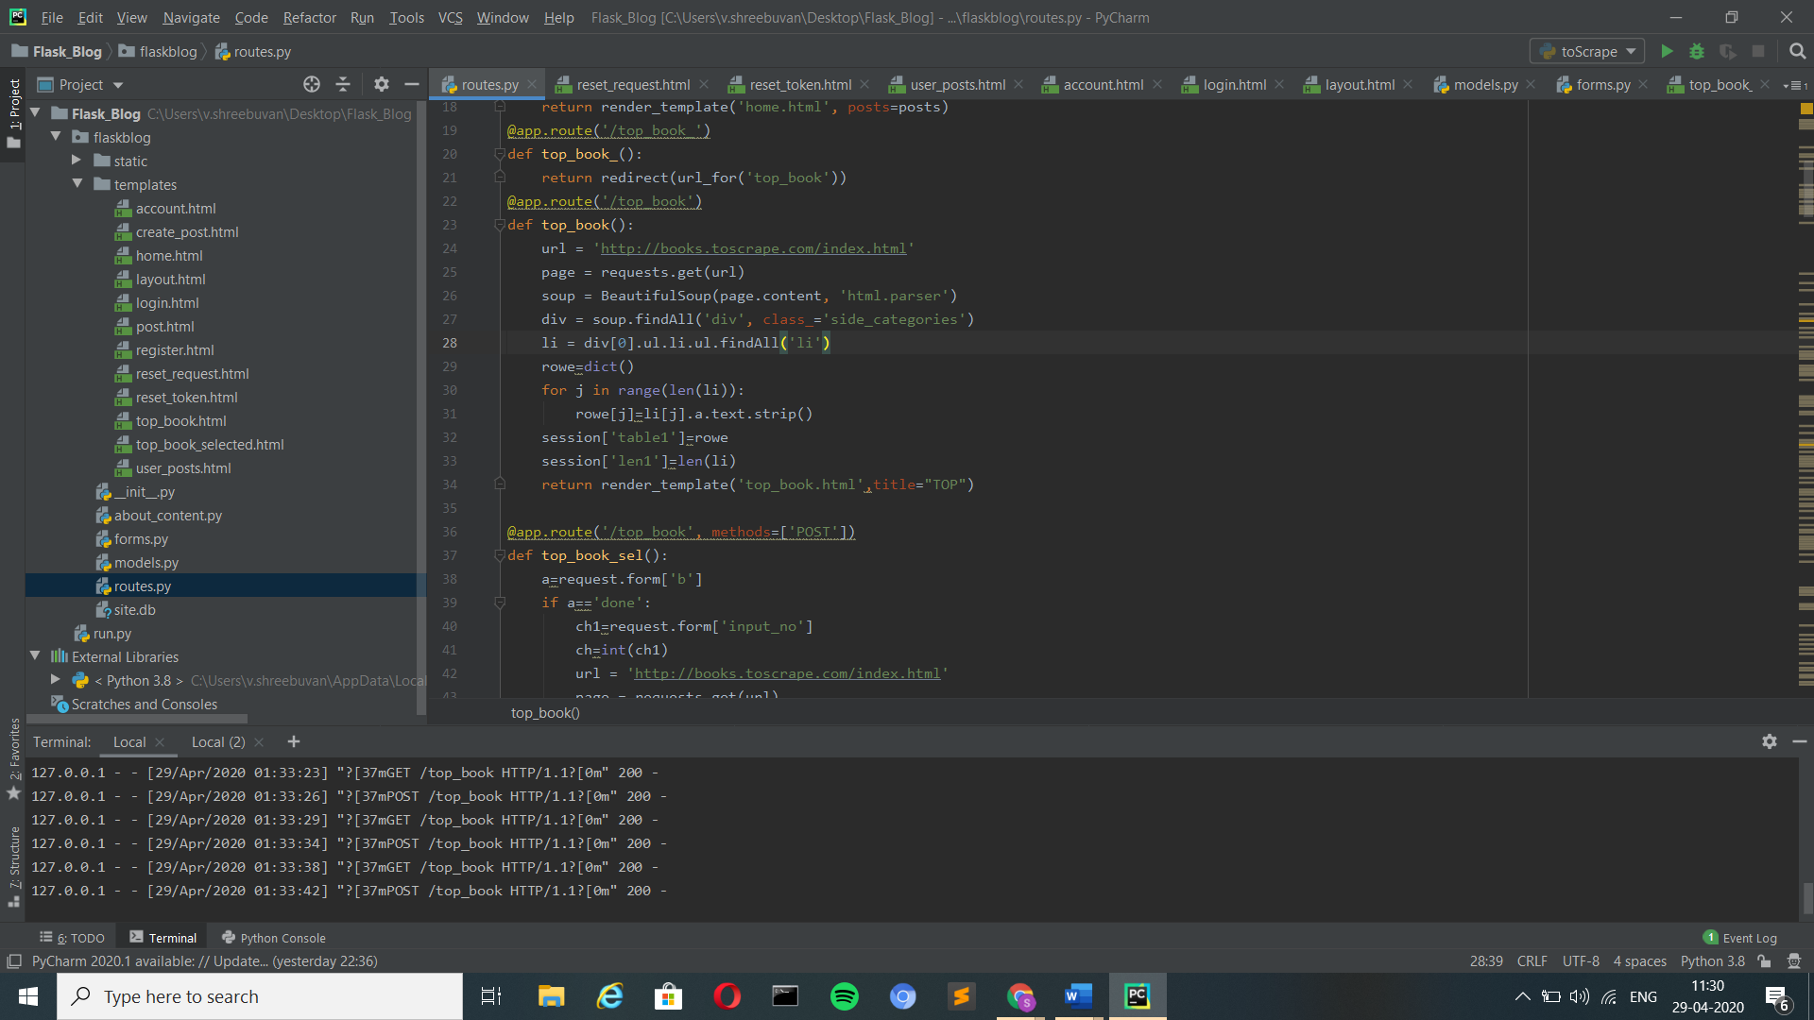

rowe is the dictionary where the key: value pair is stored which is fetched from the website and stored in session[‘table1’] and the number of categories available is stored in session[‘len1’].

* Next a session variable is used to store the category number that the user selects in the TOP Book in Selected Category.

Code:

ch is the variable where the category selected by the user will be stored. This is retrieved from the form where the user gives the number. session[‘ch’] has this value

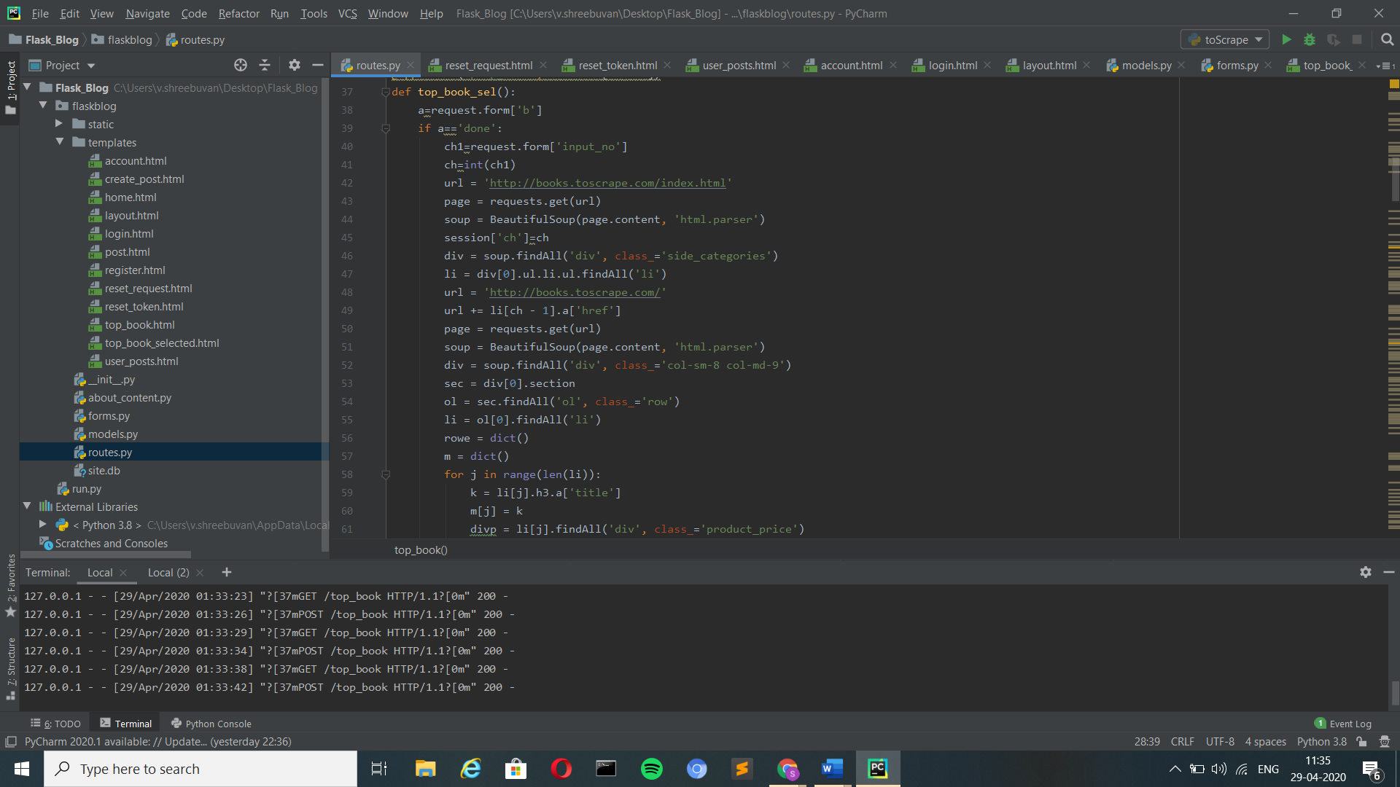

* Another session variable used to pass the results in the dictionary which contains the key: value pair of book title: price of the books in the selected category.

Code:

Selected category’s available book title: price is stored in a dictionary rowe1 which is stored in session[‘table1’]. The list m contains the titles of all the books which is stored in session[‘li’]. The number of books in selected category is available in session[‘len1’]

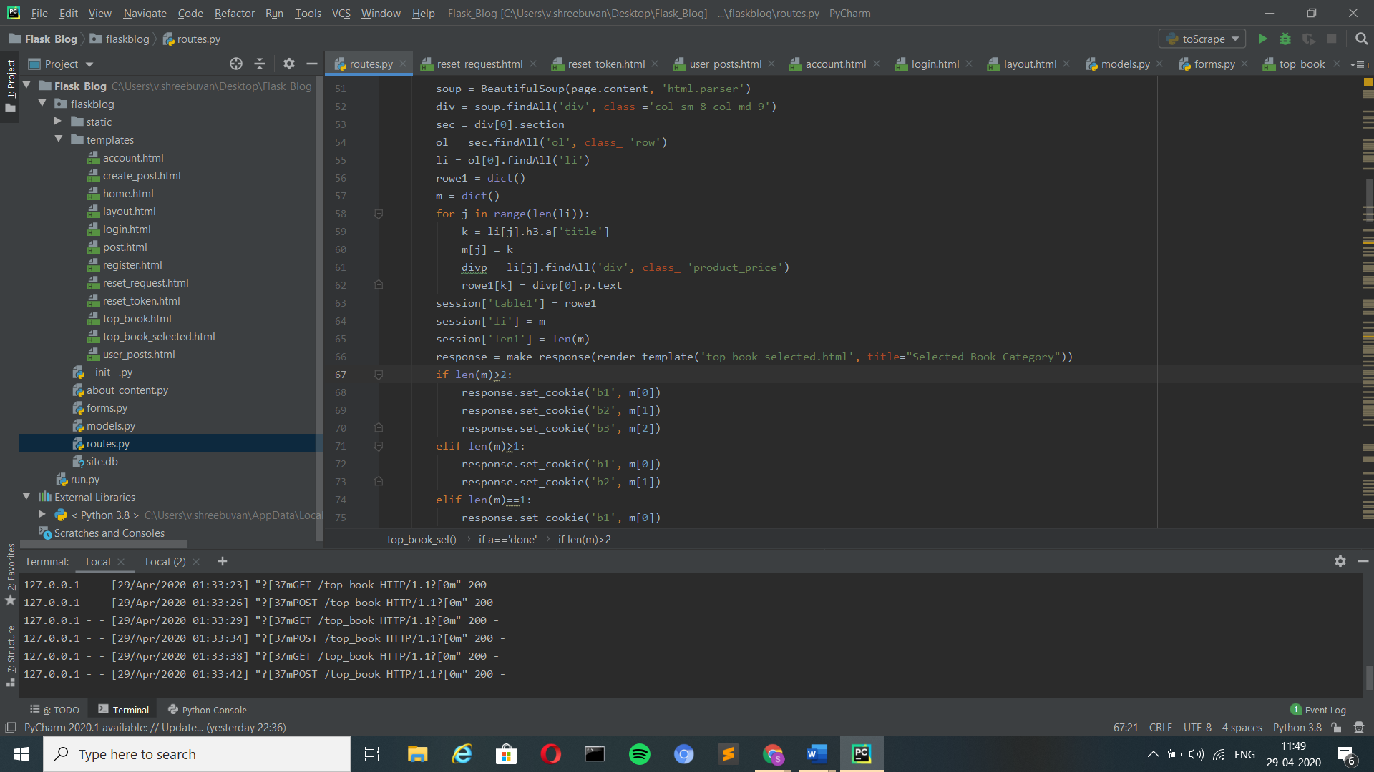

2. Cookies:

* The cookies are associated with the Request object as the dictionary object of all the cookie variables and their values transmitted by the client.

Setting Cookies:

* The cookies are set on the response object by using the set_cookie() method on the response object. The response object can be formed by using the make_response() method in the function as given below
* In this application cookies have been used to store the title of the books that users similar to them have viewed. This is shown to the users when they are in the login page.

Code:

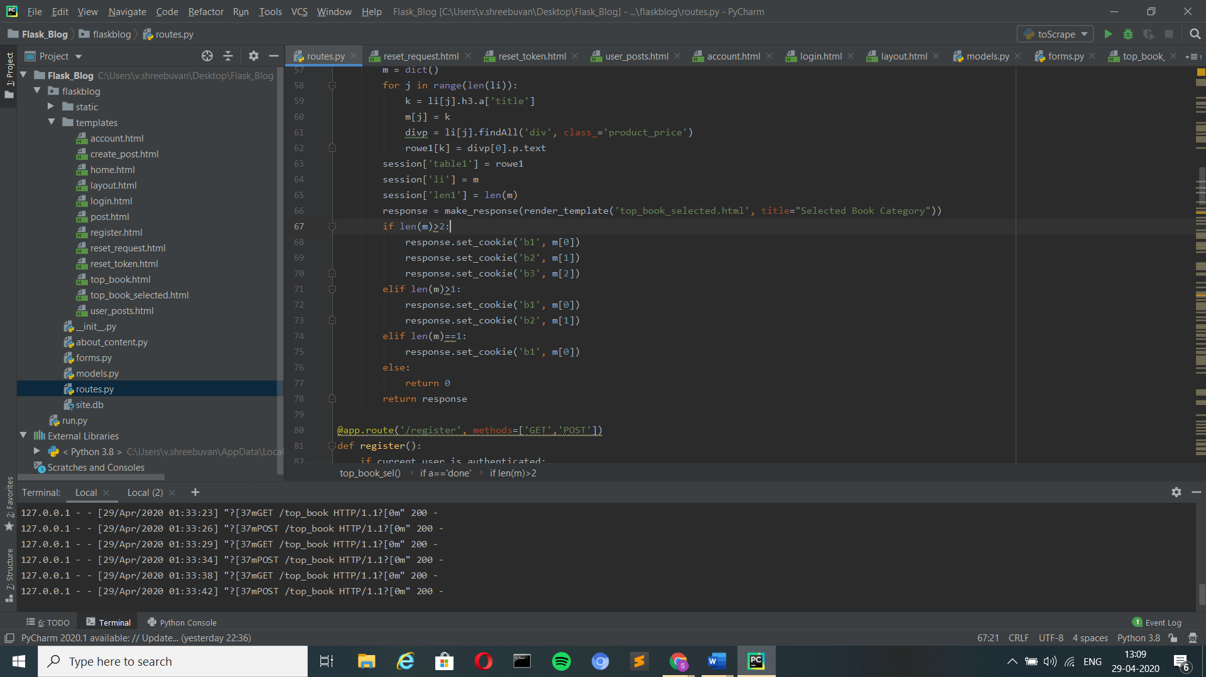

Getting Cookies:

* We can read the cookies stored on the client's machine using the get() method of the cookies attribute associated with the Request object as given below.
* In this application the book titles that are there stored in the cookies are displayed in the login page

Code:

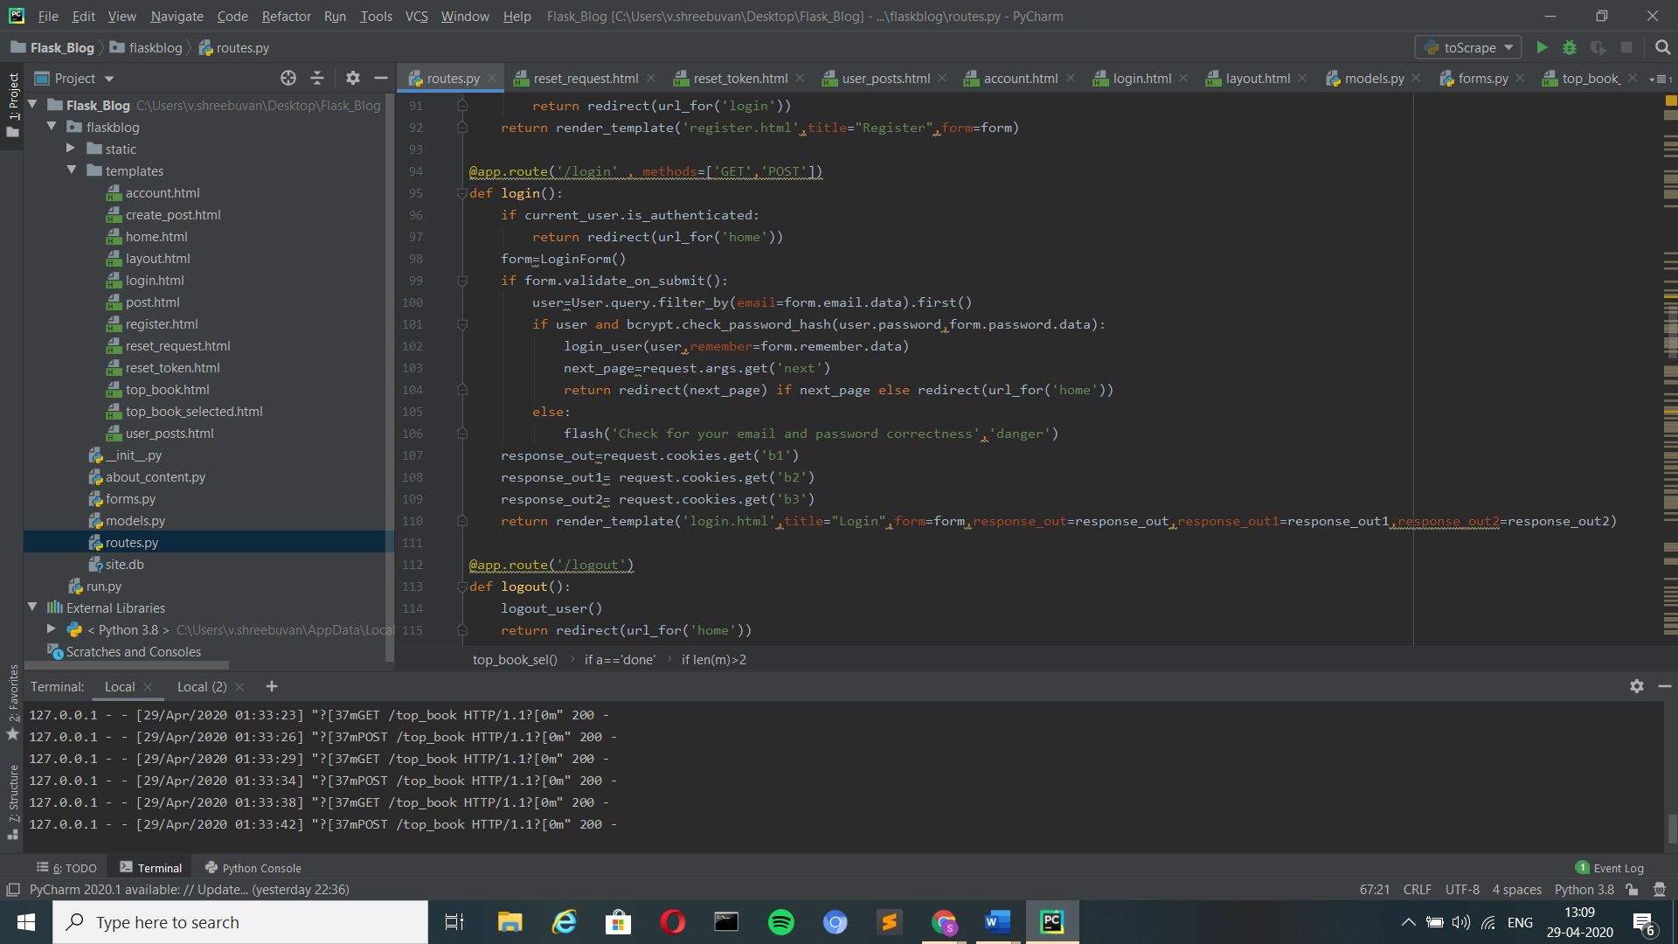

UI:

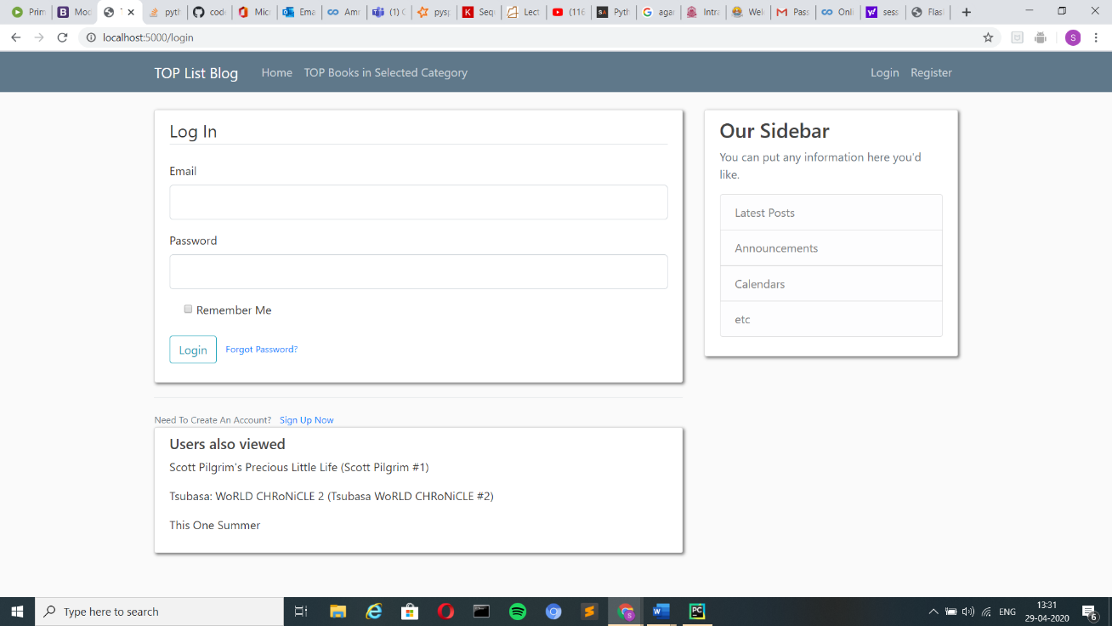

3. Error Handling:

* Generally, try: except: block is used for error handling in this application flash has been used in place for it.
* flash() does the same work as try: except: but in a still professional and appealing way in the UI.
* flash(‘Error Message’, Status)- Status in flash can be **success** i.e.)similar to code running properly without moving into except: , **danger** i.e.)similar to code having error and moving in except: , there is also two other options like **info** which is similar to giving in hint to the used when a specified process is running and **warning** which can be used for when something has to be done in a time limit.

**Status-success:**



**Code:**

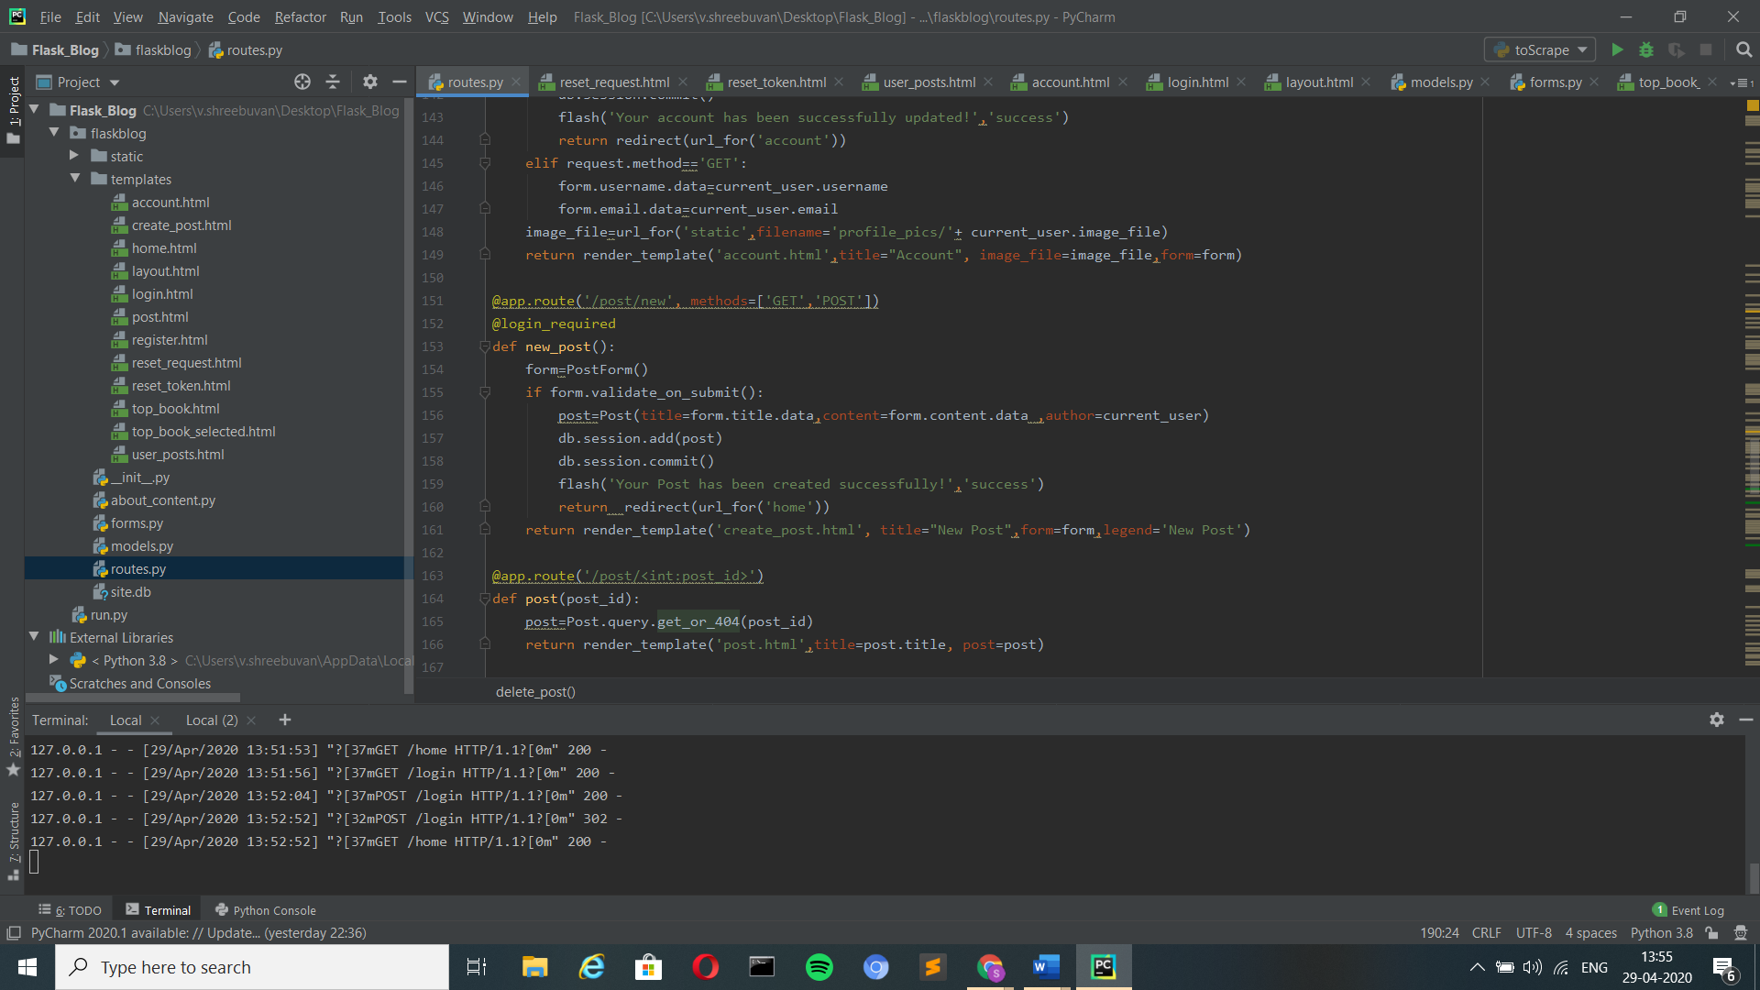

**Status-danger:**

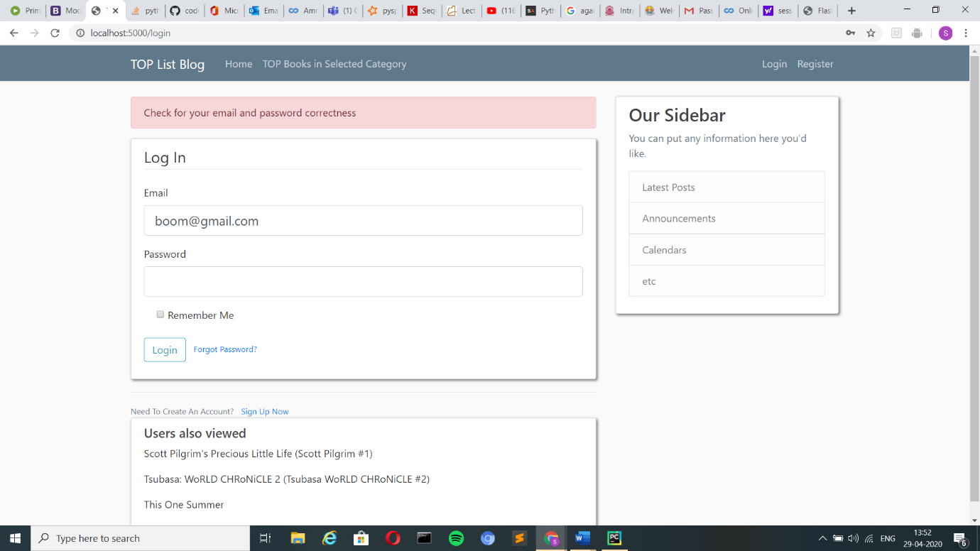

**Code:**

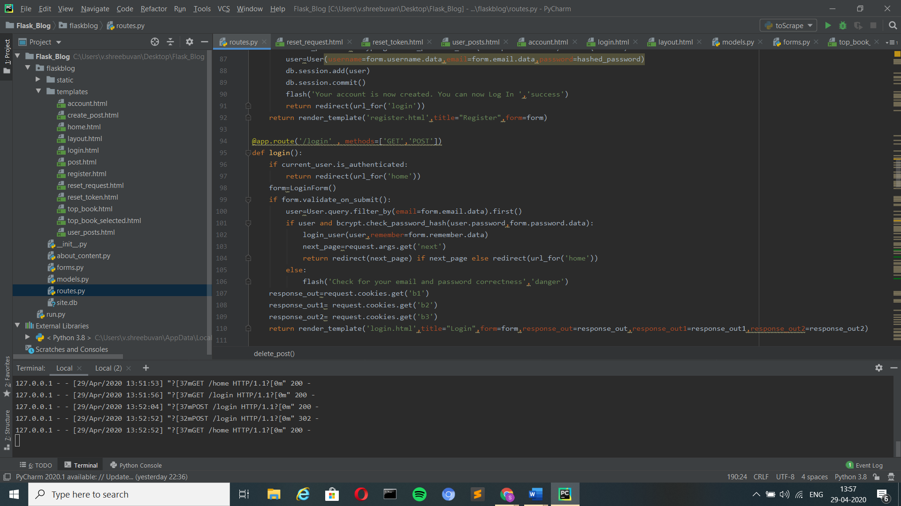

**Status-info:**

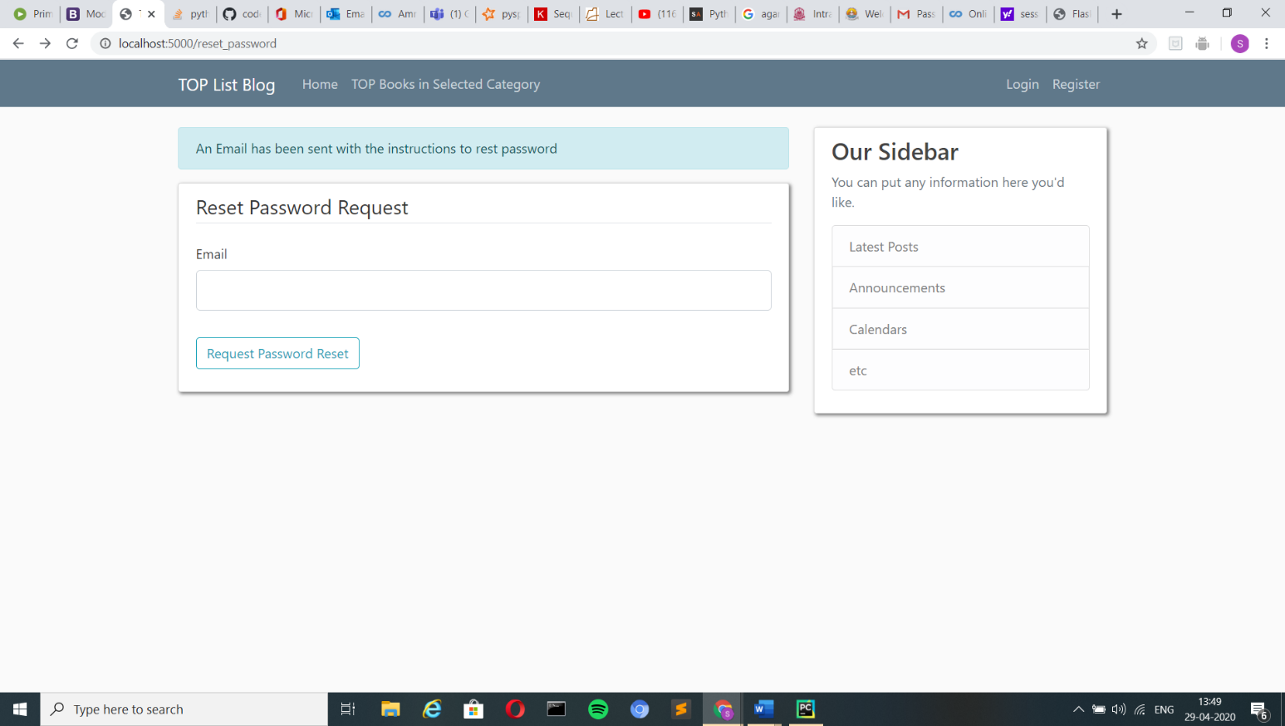

**Code:**

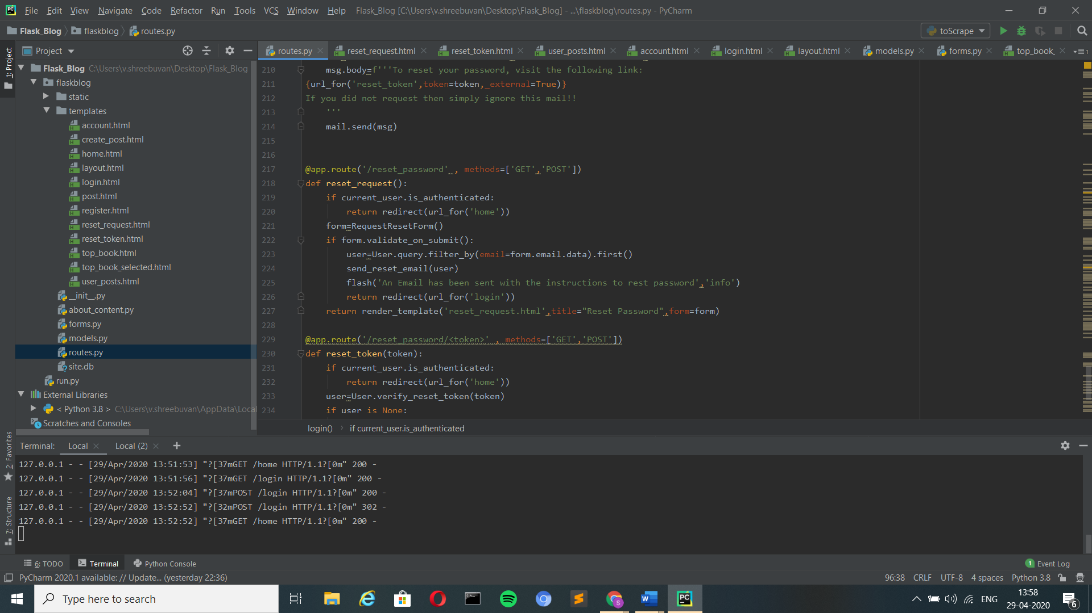

**Status- warning:**

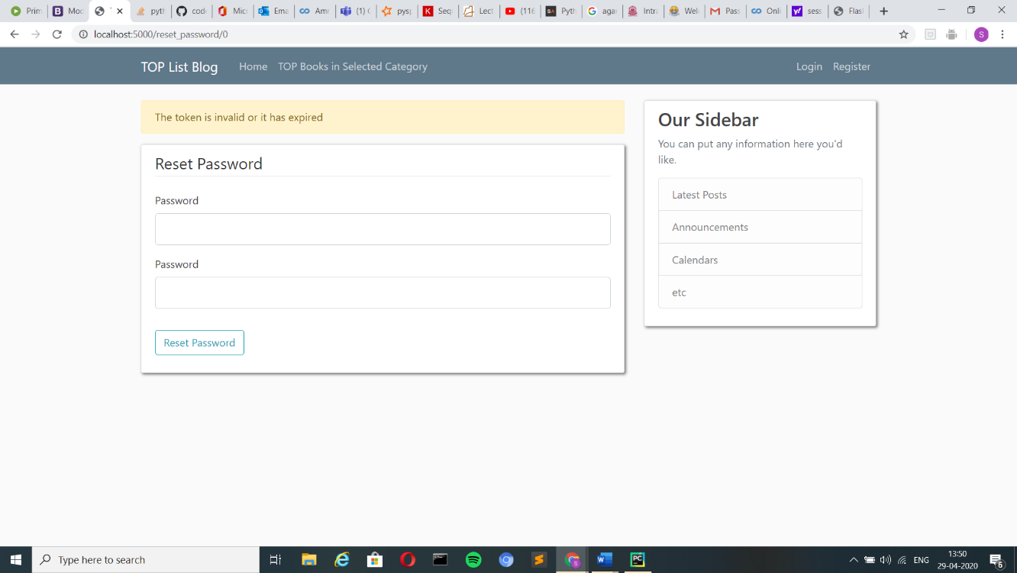

Code:

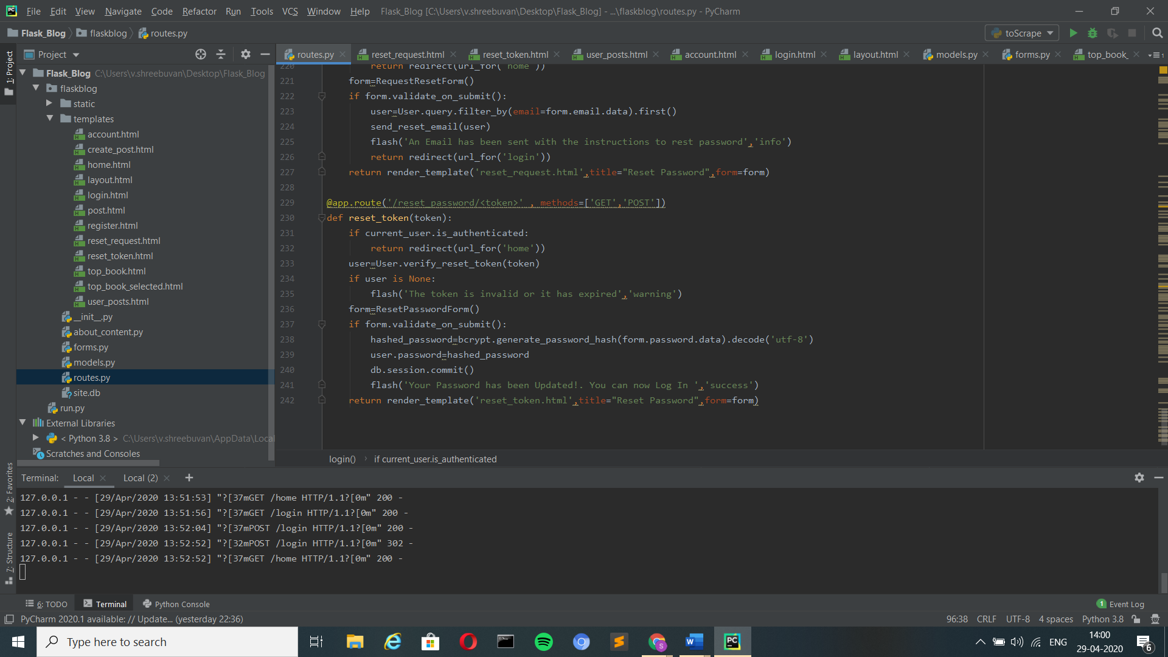

* If login is required to view a webpage and when someone tries to open it. Then the user is given with the following message.

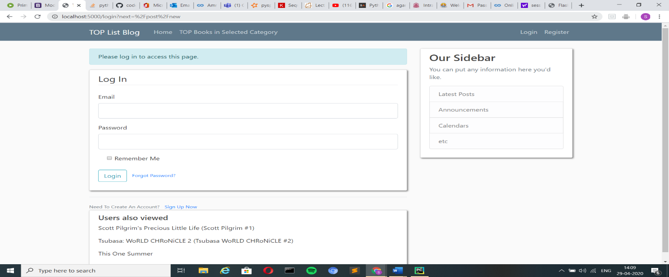

* What if user_a tries to enter the delete post page of user_b. Then the following happens

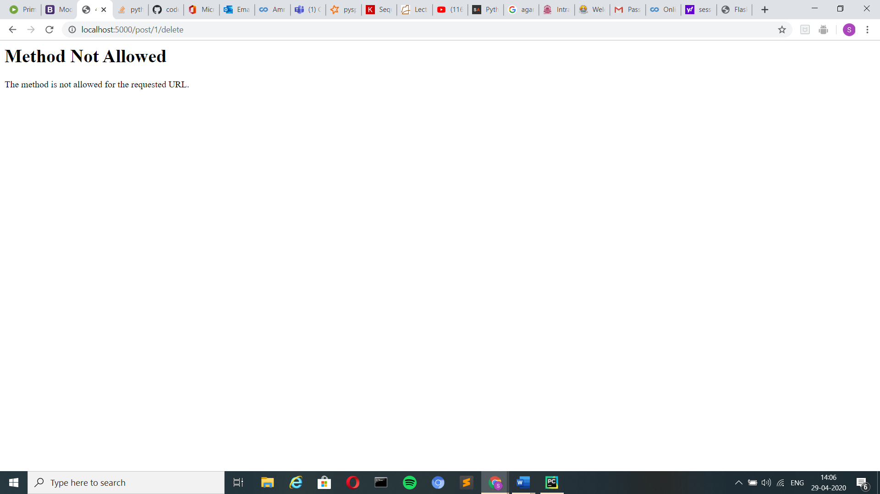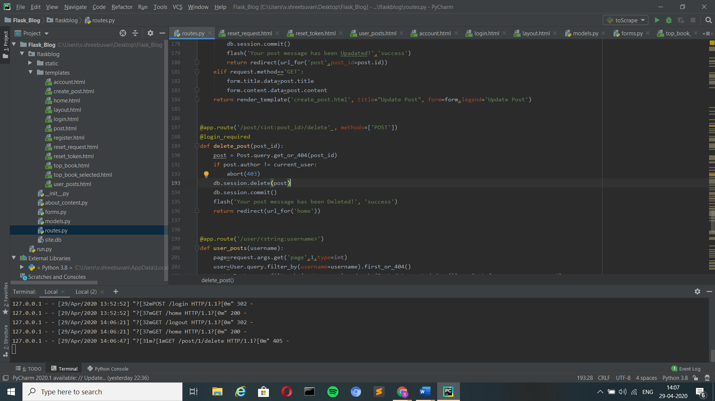

4. URLLIB/Requests:

* The request context keeps track of the request-level data during a request. Rather than passing the request object to each function that runs during a request, the [**request**](https://flask.palletsprojects.com/en/1.1.x/api/#flask.request) and [**session**](https://flask.palletsprojects.com/en/1.1.x/api/#flask.session) proxies are accessed instead.
* When the [**Flask**](https://flask.palletsprojects.com/en/1.1.x/api/#flask.Flask) application handles a request, it creates a [**Request**](https://flask.palletsprojects.com/en/1.1.x/api/#flask.Request) object based on the environment it received from the WSGI server. Because a worker (thread, process, or coroutine depending on the server) handles only one request at a time, the request data can be considered global to that worker during that request. Flask uses the term context local for this

5. Beautiful Soup:

* It is a Python library for pulling data out of HTML and XML files.
* The below code snippet shows the code for Beautiful soup and request.get() that has been used in the project.

Code for both request and beautiful soup:



6. Serializer:

* Used for generating token when a user requests for reset password which will expire in 1800ms (developer specifies it).
* This token’s validation will be checked as when the user is directed to the reset password page.

Code:

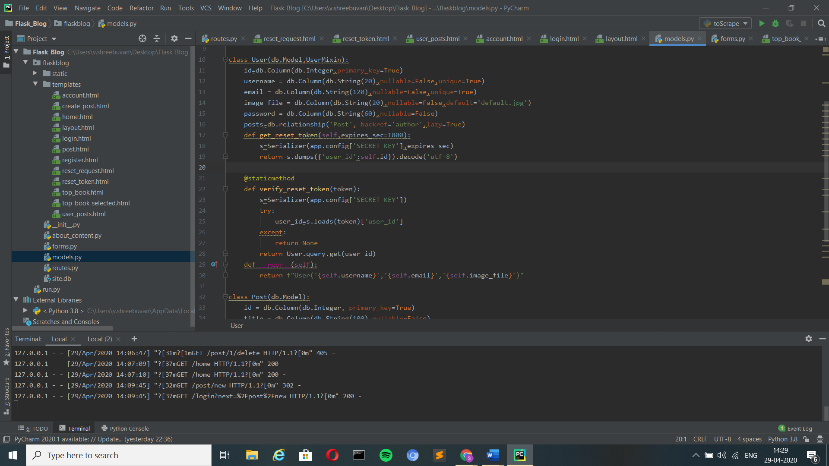

If Token Expires:

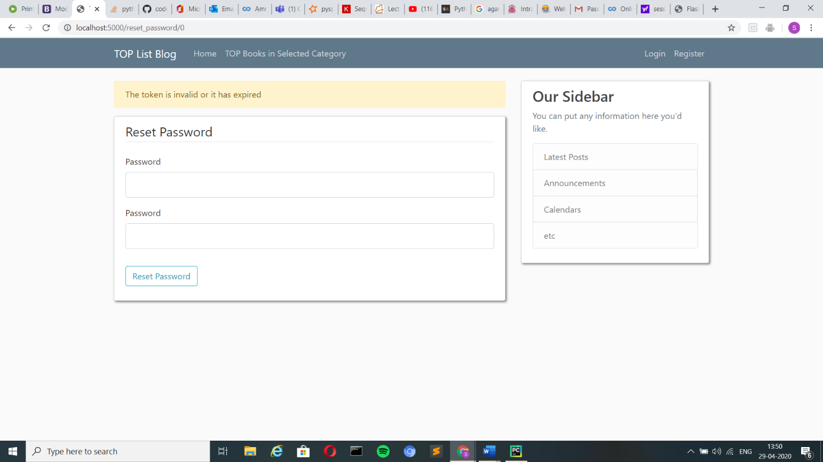

7. Hashing:

* Hashing is a method by which the user’s password is encrypted and is decrypted in the server side and is checked with the password entered by the user.
* As each password entered by the user will have a unique hashing which will be checked with the actual password in the database given by the user during registration.

Code:

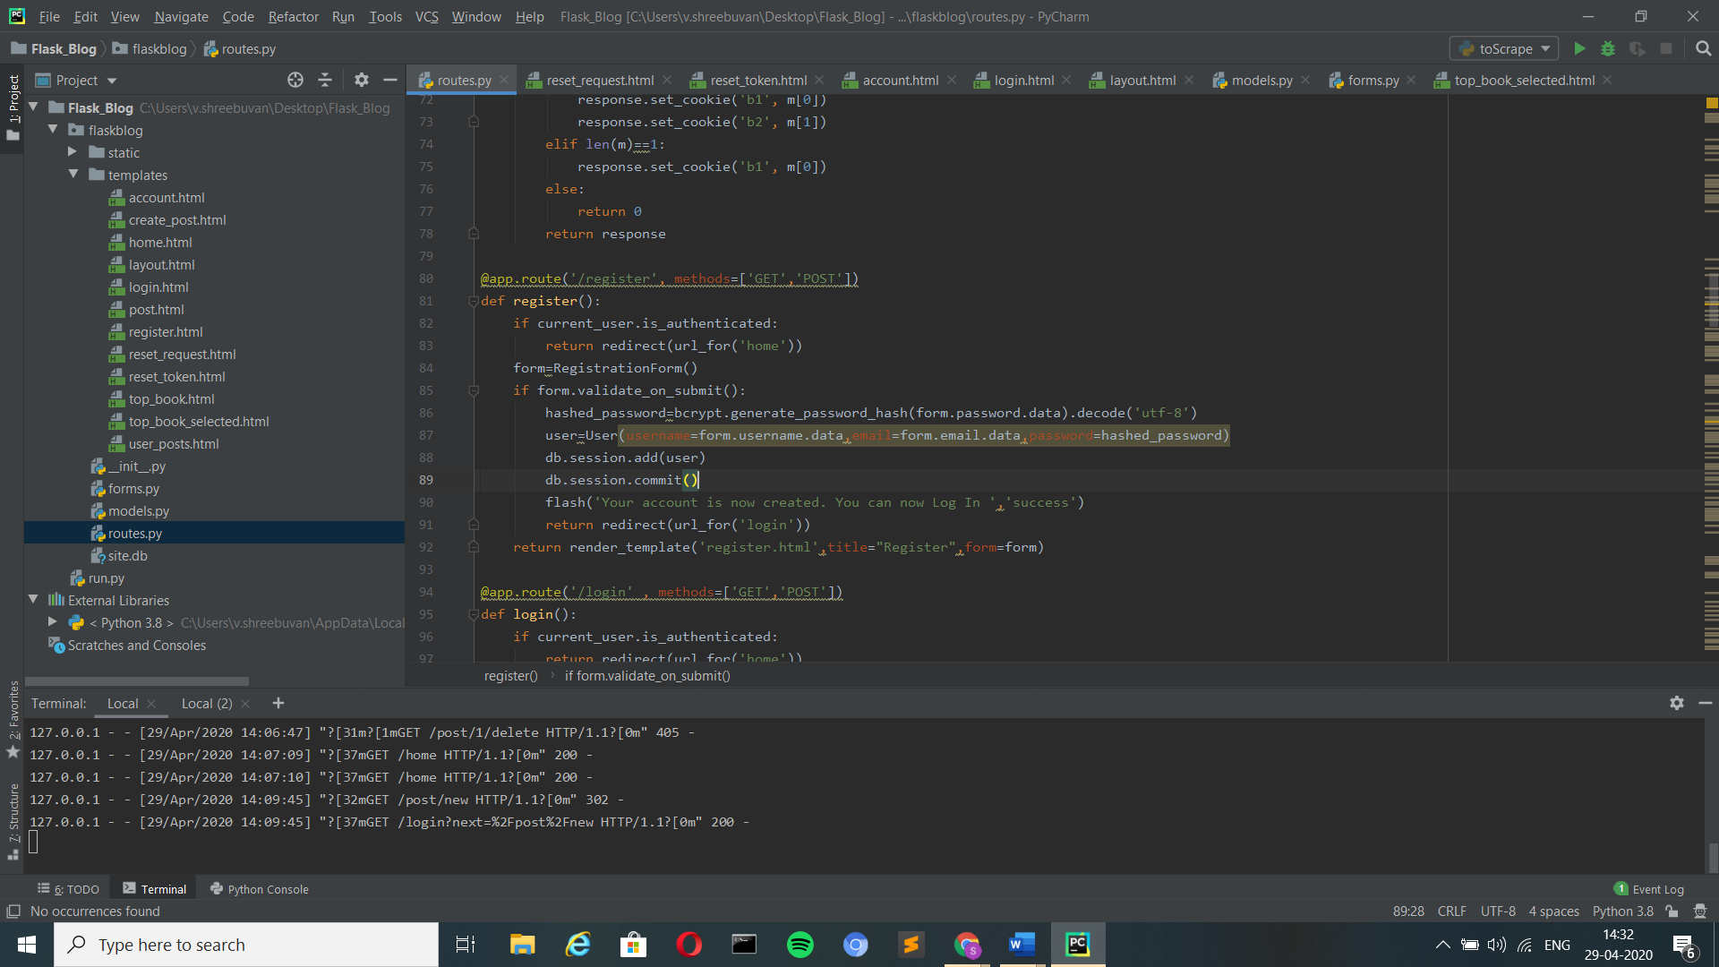



Additional Information and Requirements:

* App has a secret key without which running the web-application is not possible which is present in the file __init__.py.
* This application uses the SQLite database and there is no need of the software to be installed in the system as the code will take care of it.
* There is also the file named site.db which is the database which is included with the other files.
* See to that all the needed packages are installed in the system in which this application is going to tested on.
* The application can run in any environment but PyCharm or Command prompt is more preferable.
* Another remainder regarding the reset password feature. This feature will work only when the user has given access to less secured app to access his/her google account. (Reference: https://support.google.com/accounts/answer/6010255?hl=en, https://hotter.io/docs/email-accounts/secure-app-gmail/)